Grace Long Torales

PENeo03

1. MERGE (walsh:People {name:"John Walsh"})-[:LIVES_IN {since:"20141102"}]->(rochester:City {name:"Rochester"})

MERGE (person:People {name:"Sally Person"})-[:LIVES_IN {since:"20141102"}]->(dubrovnik:City {name:"Dubrovnik"})

MERGE (baker:People {name:"James Baker"})-[:LIVES_IN {since:"20130901"}]->(zagreb:City {name:"Zagreb"})

MERGE (lindsey:People {name:"Carol Lindsey"})-[:LIVES_IN {since:"20130815"}]->(syracuse:City {name:"Syracuse"})

MERGE (smith:People {name:"John Smith"})-[:LIVES_IN {since:"20110401"}]->(dubrovnik)

MERGE (walsh)-[:FRIEND_OF]->(baker)

MERGE (baker)-[:FRIEND_OF]->(walsh)

MERGE (person)-[:FRIEND_OF]->(lindsey)

MERGE (lindsey)-[:FRIEND_OF]->(person)

MERGE (baker)-[:FRIEND_OF]->(smith)

MERGE (smith)-[:FRIEND_OF]->(baker)

MERGE (walsh)-[:FRIEND_OF]->(smith)

MERGE (smith)-[:FRIEND_OF]->(walsh)

MERGE (walsh)-[:MANAGES]->(person)

MERGE (walsh)-[:MANAGES]->(baker)

MERGE (walsh)-[:MANAGES]->(smith)

1. MATCH (n)

OPTIONAL MATCH (n)-[r]-(m)

RETURN COLLECT(DISTINCT n) AS nodes, COLLECT(DISTINCT r) AS relationships

Results:

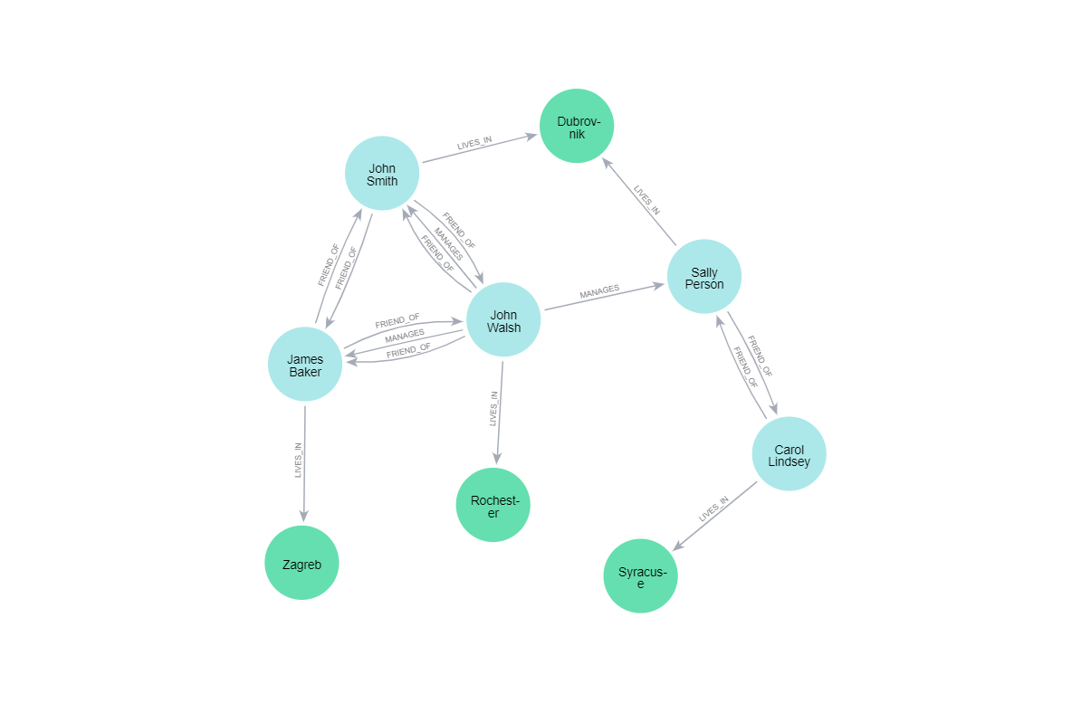

1. MATCH (n:People)

WITH n, SPLIT(n.name, " ")[0] AS firstName

WITH firstName, COUNT(firstName) AS repeats WHERE repeats > 1

MATCH (n:People WHERE SPLIT(n.name, " ")[0] = firstName)

RETURN n

Results:

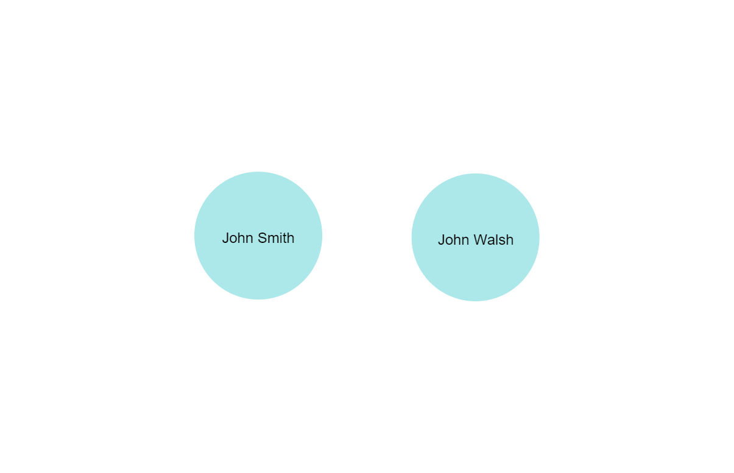

1. MATCH (n:People)-[r1:LIVES_IN]->(c)<-[r2:LIVES_IN]-(m:People)

RETURN n, r1, c, r2, m

Results:

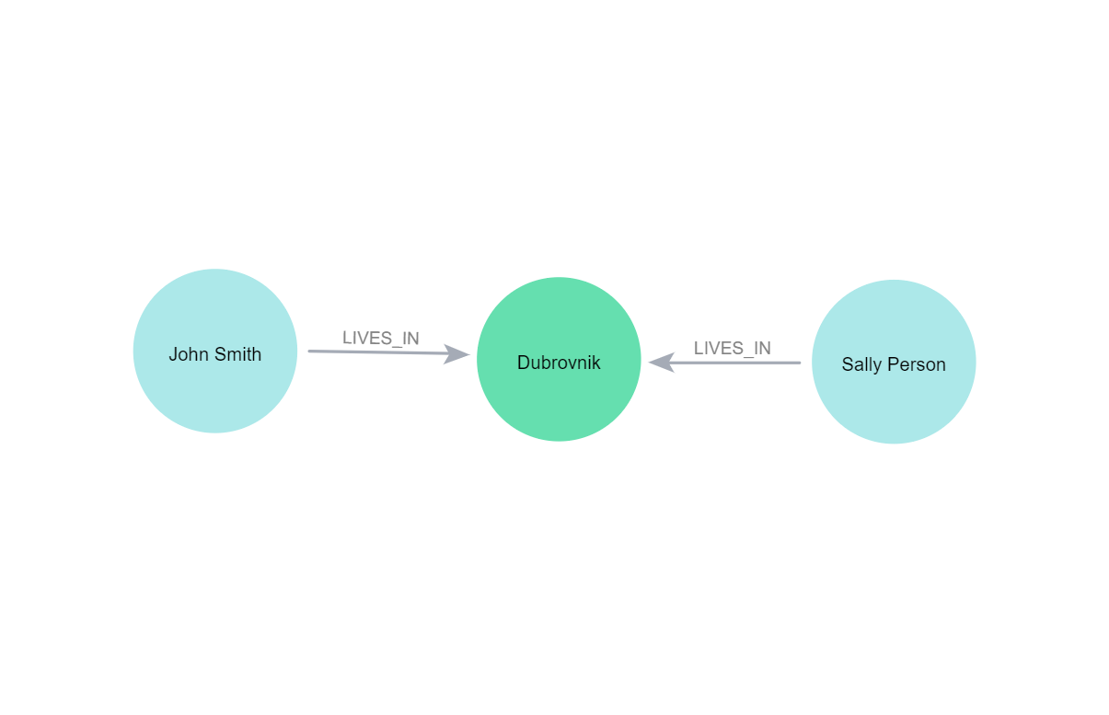

1. MATCH (n)-[r:LIVES_IN]->(c:City {name:"Dubrovnik"})

RETURN n, r.since

ORDER BY r.since

LIMIT 1

Results:

1

(:People {name: "John Smith"})

"20110401"

1. MATCH (baker:People WHERE baker.name CONTAINS "Baker")-[original:LIVES_IN]->(c)

MATCH (rochester:City WHERE rochester.name CONTAINS "Rochester")

DELETE original

MERGE (baker)-[:LIVES_IN {since:”20151126”}]->(rochester)

MATCH (n)

OPTIONAL MATCH (n)-[r]-(m)

RETURN COLLECT(DISTINCT n) AS nodes, COLLECT(DISTINCT r) AS relationships

